MacGraw Hideaway
A 1st-Level Adventure for Draw Steel
by Look Out Behind You Studios

“MacGraw Hideaway” is an independent product published under the DRAW STEEL Creator License and is not affiliated with MCDM Productions, LLC. DRAW STEEL © 2024 MCDM Productions, LLC.
MacGraw Hideaway © 2025 Look Out Behind You Studios LLC

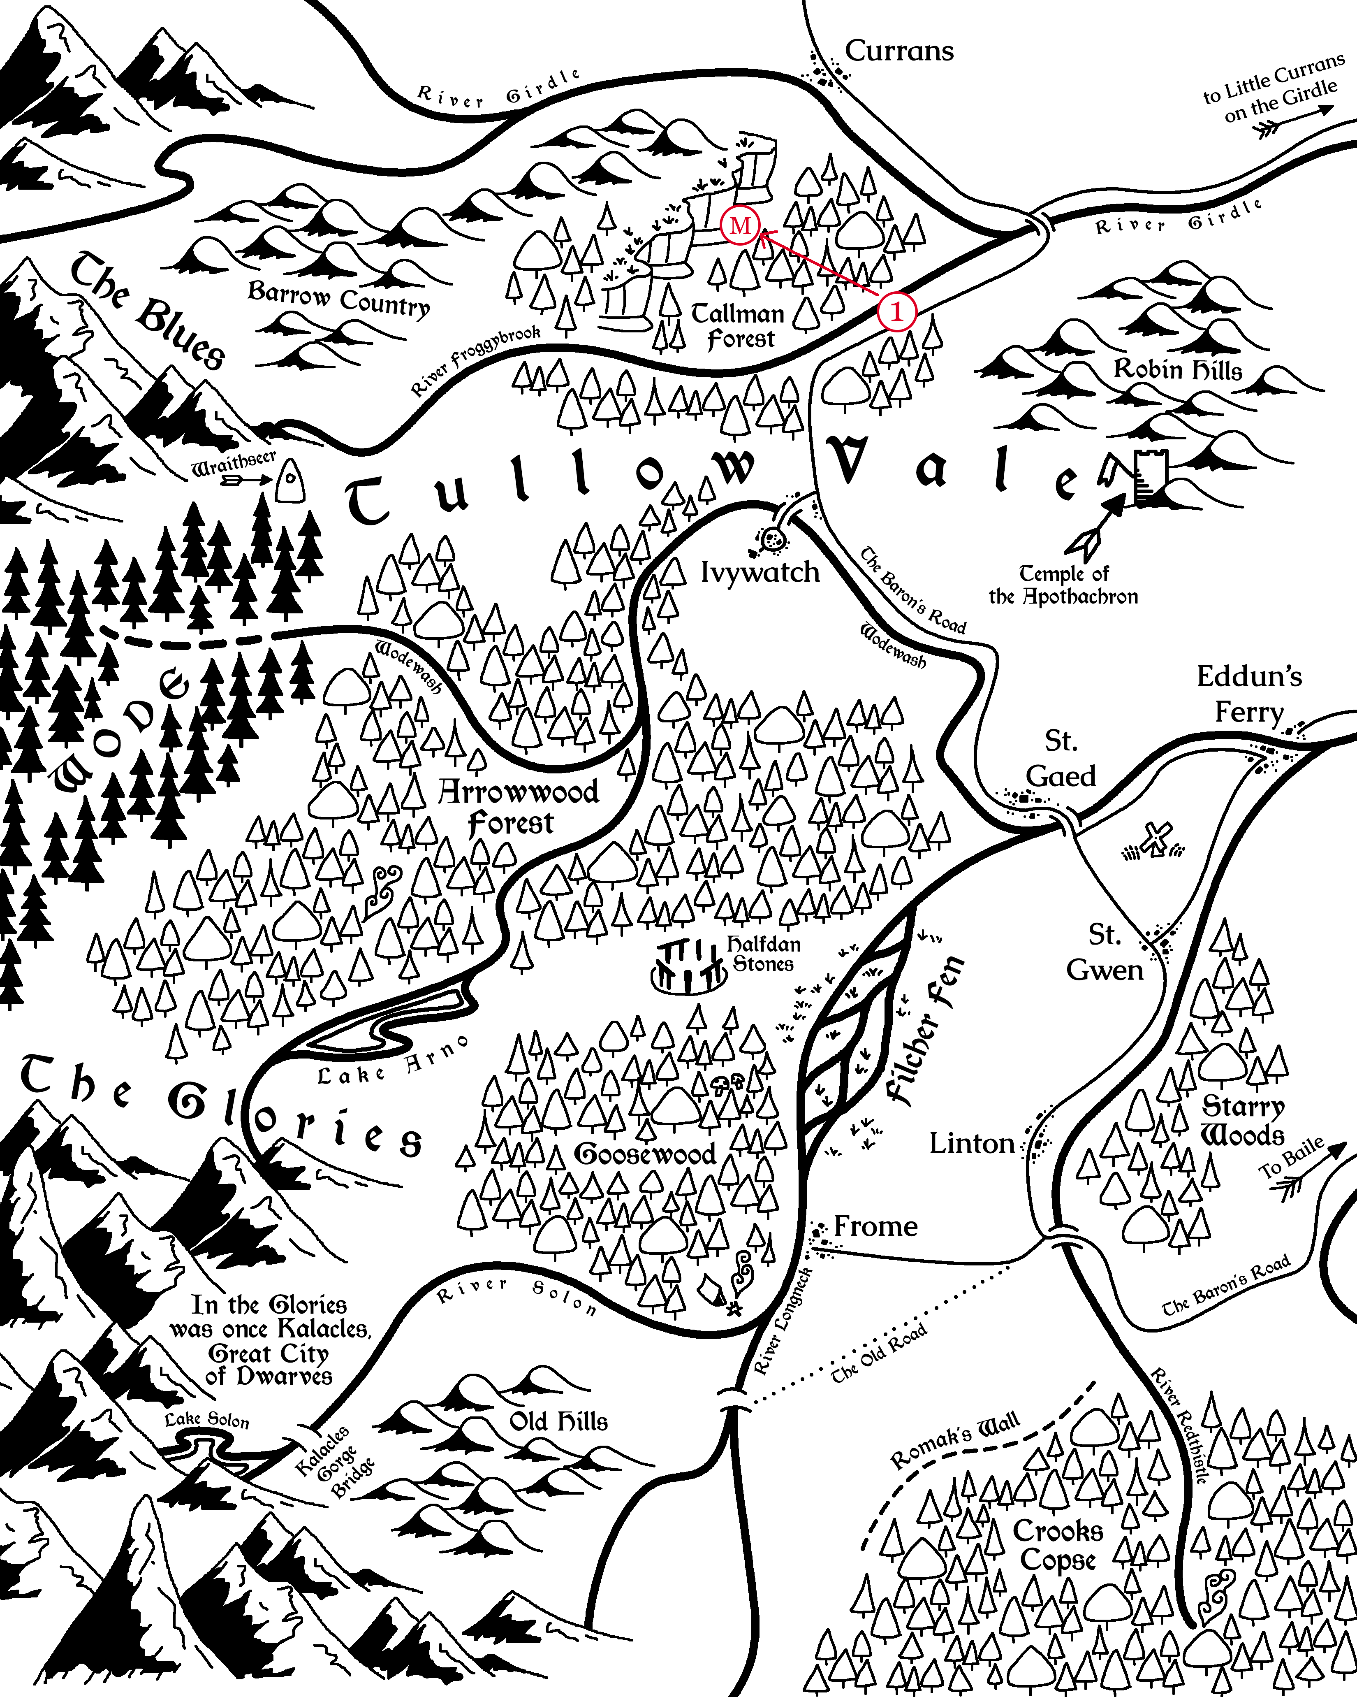
Marked in red are the scenes of the adventure (1: Scene 1, M: Scenes 2 & 3).

MacGraw Hideaway
MacGraw Hideaway is an adventure set in Vasloria, a woody, humid, and vaguely Europe-like region of Orden. The adventure is designed for two to seven 1st-level heroes and grants between 2 and 6 Victories.

MacGraw Boss, Blarg
The lizardfolk necromancer Deatheye Yslansh wants to summon the Avatar of Torment, Excrucior Interfectus to wipe out Tullow Vale and leave behind a wasteland of death for her to lord over.

BLARG ART HERE

Adventure Hook
MacGraw Hideaway assumes the following adventure hook.
Trademark Violation: The last few weeks, goblins have been attacking merchants along the Baron’s Road in Tallman Forest and kidnapping victims. The Company of Cordwainers have been hit the hardest by the attacks, but were content to let the local authorities handle it in their own time, until the goblins gained the moniker of the “MacGraw Tribe.” Tybald MacGraw, the guildmaster of the company, doesn’t like sharing, least of all his name.
The company sends a contact to the heroes in Currans with a job: eradicate the creatures from their hole.

Guide to Tullow Vale
Tullow Vale is tucked in between the foothills of the Myr Mountains of Vasloria, with farmland to the east and elf-haunted wode to the west.

The Central Tension
Long ago, an ancient civilization in Tullow Vale was ruled centrally by a single dwarven king in the great city of Kalacles. In the wake of Ajax’s campaign and the death of the more recent, local Vaslorian duke, the lords of Tullow Vale now question whether to retain the town-and-lord system, paying taxes to but not protected by a distant and apathetic baron, or to centralize power under the Old Ways and choose a new King of the Vale.
Nearby Faction Leaders
Here are some faction leaders that are nearby, but do not appear in this adventure.
Tybald MacGraw, Guildmaster of the Company of Cordwainers
“The company knows every boot in the Vale. Where it’s been and where it’s going.”
Guildmaster MacGraw foresees the greatest profit in the Capital of a centralized Vale.

Penwyn Craddock, Lord of Currans
“First godsdamned week of harvest and half the carters are missing or dead! Makes us look like a hamlet!”
Lord Craddock has an economic plan to make Currans a regional market city and doesn’t want to compete with some other Capital.

Scenes
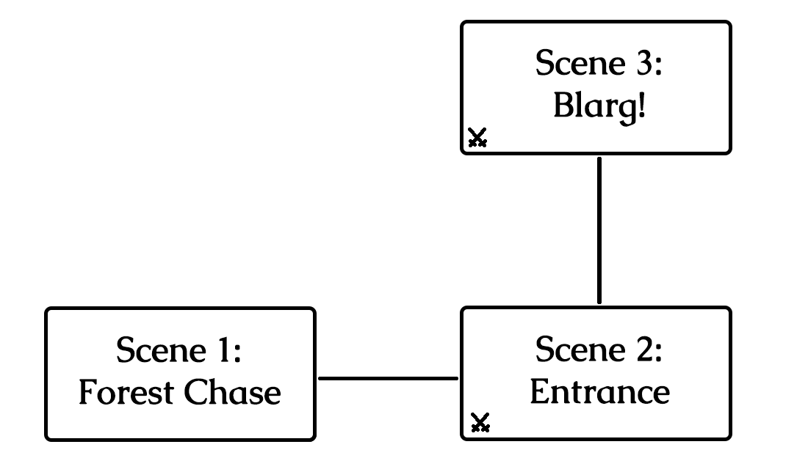
The scenes and how they connect in the adventure.

Scene 1: Forest Chase
The contact in Currans told you scant details, but ultimately the job was very simple: eradicate the goblins terrorizing Tallman Forest from their hole and save the company’s journeyman, Silvester Fallwinter, if he lives.
And so you set out and here you are, on the Baron’s Road heading south from Currans.
Boxed, italicized text like this is meant to be read aloud to your players!
Dir. Note: Director notes like this contain information the players should not be told!
Take a moment to do the following:
- Encourage the players to introduce their heroes if they haven’t already.
- Each of the heroes are each well-known in some region, if not this one. Ask each player what the title is of the most popular bard’s song about their hero’s exploits.
- Ask the players how their heroes each spend evenings in camp while on the road and which of their senses they most rely on while searching for goblins.
Every tree in Tallman Forest seems to hide an extra shadow. Every bird’s song sounds a little suspicious.
Suddenly, a scream from a bit further down the road interrupts your focus, and then hones it.
You were just a step to late! As you round the corner, you see the last goblin hit a victim over the head and haul their unconscious body into the forest away from their burning caravan.
Goblins are well known for their ambushes. No normal person would willingly follow a tribe through their home turf.

Following the goblin tribe through their forest is a recipe for disaster without taking extreme care. But if the party takes too much care, they won’t be quick enough to follow!
The party attempts a Medium Intuition Group Test to keep an eye out for goblin tricks and traps.
- Fewer than half succeed: The party feels eyes watching them from somewhere, but they can’t tell from where exactly. In the upcoming combat encounter, the heroes can start anywhere within the box marked “START.”
- Half or more succeed: The party smells blood in the air and they see no guards on the battlements of the town. In the upcoming combat encounter, the heroes can start anywhere they choose on the map.
The party attempts a Medium Agility Group Test to follow the goblin tribe and not loose track of them.
- Fewer than half succeed: The party feels eyes watching them from somewhere, but they can’t tell from where exactly. In the upcoming combat encounter, the heroes can start anywhere within the box marked “START.”
- Half or more succeed: The party smells blood in the air and they see no guards on the battlements of the town. In the upcoming combat encounter, the heroes can start anywhere they choose on the map.

Scene 2: Entrance
The MacGraw goblins guard their encampment lazily, lounging by the campfire or staring off into the distance. Two of them prod a captured merchant, tied up in a cage. The merchant screams and the goblins laugh.
No one is aware that you’ve arrived. For now, the captive merchant is completely without hope, but in the meantime, you have the element of surprise!

The heroes begin hidden and in the box marked “START.” The positions of all enemies are immediately detectable. Heroes take turns as if in combat, but as long as each turn ends with all heroes hidden, combat will not begin and enemies will not take turns.
Once the enemies are aware of the heroes, combat begins with the enemies surprised! Draw steel!

Draw Steel! “Entrance”
The MacGraw goblins retreat into their cave and try to kill the hostages on the way.
Earn 1 Victory for preventing any goblin non-minion from reaching the box marked “ESCAPE.”
Earn 1 Victory for freeing all hostages while they live.
- Each ledge and wooden platform is 2 squares tall.
- Standing trees are 2 squares tall and provide cover and concealment.

Dir. Note: Secret Tunnel
If the heroes enter the worg pen at any point, they automatically spot a size 1T crack in the wall between some boulders. The crack leads to an 8 square tall shaft, which leads further into the cave. A size 1T hero can fit through the crack, or the crack can be busted wide open by destroyed or otherwise removing 1 square of stone.
If the heroes take the secret tunnel, continue to Scene 3 and skip ahead to the “Rock Throwing Contest.”

Party Size | Malice – Goblins  Enemy Forces:
2+ | Squad A: 4 Spinecleavers (m)  Squad B: 2 Worgs  Squad C: 2 Spinecleavers (m)  Non-Minion A: 1 Cursespitter  Non-Minion B: 1 Cursespitter
3+ | Squad D: 4 Snipers  Squad E: 4 Spinecleavers
4+ | Non-Minion C: 1 Warrior
5+ | More Non-Minions: 1 Warrior per extra hero beyond party size 4

Handling Hostages
- Each hostage has 8 Stamina.
- A hero (or retainer) can free all hostages adjacent to them them using a single maneuver.
- Freed hostages deftly and immediately escape the combat, leaving the encounter.
- An enemy can grab a hostage as a maneuver. An enemy grabbing a hostage can move freely, bringing the hostage with them, but cannot convert their main action into a move action.
- A hostage can be freed from an enemy holding them by killing the enemy, making the enemy prone, or by force moving the enemy off of their square,

Dir. Note: Tactics

The first goblin minion to take a turn will unleash a shrill whistle. The worgs will move 15 squares (2x move action + maneuver) to get to the minion.

Minions: harass the heroes will the non-minions escape. Let the minions ride the worgs. If a non-minion were to ride a worg, they would escape too easily.

Spinecleavers can push heroes off of ledges to make them take falling damage!

Non-minions: first, move as fast as possible to a hostage. Grab the hostage and then begin moving as fast as possible to the box marked “ESCAPE.”

Following the Stream
If the heroes follow the stream further into the cave, continue to Scene 3.

Scene 3: Blarg!
A human scream is drowned out by the dull roar of a waterfall echoing off the slimy walls as the tunnel opens into a large cavern. Tall ledges hide what lays beyond, further inside. Torchlight from around the corner threatens to expose any foolish enough to trespass into the goblin’s den.

The heroes begin hidden and in the box marked “START.” The positions of enemies in “FOG AREA 1” are immediately detectable, but “FOG AREA 2” remains hidden. Heroes take turns as if in combat, but as long as each turn ends with all heroes hidden, combat will not begin and enemies will not take turns.
Once the enemies are aware of the heroes, go to “Blarg’s Introduction.”
- Each ledge and wooden platform is 2 squares tall.
- Silvester has 21 Stamina.

The Lonely Worg
Nearby in its blood-spattered pen is Meatmunch, one of the goblins’ worgs.
Heroes who enter the pen must succeed on a Medium Presence Group Test to placate the worg or it will alert the nearby sniper and the rest of the cavern to the heroes’ intrusion.

Rock Throwing Contest
When the first hero reaches a position at least 4 squares higher than the stream’s outlet, read the following:
The sound of rock hitting metal punctuates the echoes in the cavern. You spy the source: a vile rock throwing contest. A beefy goblin steps up on a boulder and tosses a stone at a pair of cages, each holding one of the kidnapped merchants. The goblin pegs the hostage in the head and they collapse. They won’t be able to take many more.

After reading the Rock Throwing Contest passage, reveal the rest of the cavern (“FOG AREA 2”) and the positions of all the enemies.
While combat has not yet started, after each turn the heroes take, another goblin throws a rock at the hostages. Roll 1d3:
1 | The rock misses and the goblins laugh.
2 | The left hostage takes 2 damage.
3 | The right hostage takes 2 damage.

Blarg’s Introduction
A nasally, sonorous voice fills up the cavern.
“WHO DARE DEFY BLARG?”
A hulking bugbear dressed in mismatched flamboyant silks walks to the edge of the highest ledge, back-lit by a fire pit. He holds a bound human man: Silvester Fallwinter.
“PARLEY WITH BLARG! OR MAN GO SWIM!”
Blarg gestures to the pool beneath him. The captive man yells out.
“Don’t trust it! Forget me and save the others! The beast cannot be reasoned with!”

If the heroes choose to parley, go to “Negotiation with Blarg,” otherwise, Draw steel!

Parley with Blarg
Blarg has gotten this far as leader of the tribe with more than just brawn. He’s a skilled diplomat, at least for a bugbear. If the heroes choose to parley, they enter a Negotiation with Blarg.
Blarg has to maintain an image in front of his tribe, in spite of his personal feelings, and thus has very different negotiation stats depending on what language the negotiation proceeds in.
Dir. Note: The heroes can potentially reason what language Blarg prefers with a skill test.
Caelian | Blarg, the Chief
Szetch | Blarg, the Chief
Khelt | Blarg, the Exile

Blarg, the Chief
- Interest: 1
- Patience: Caelian 2, Szetch 3
- Impression: 1

Motivations:
- Higher Authority – Bleddyn respects the chain of command and is honored to serve Knight Andreja. Bleddyn admires Paladin Millicent and thinks she ought to be Commander.
- Protection – As goes the oath of the Oak Shields Company of the Knights of Golden Ivy, Bleddyn “shelters the Vale” and never wavers.

Pitfalls:
- Higher Authority – Bleddyn respects the chain of command and is honored to serve Knight Andreja. Bleddyn admires Paladin Millicent and thinks she ought to be Commander.
- Higher Authority – Bleddyn respects the chain of command and is honored to serve Knight Andreja. Bleddyn admires Paladin Millicent and thinks she ought to be Commander.

Blarg, the Exile
- Interest: 2
- Patience: 3
- Impression: 1

Motivations:
- Higher Authority – Bleddyn respects the chain of command and is honored to serve Knight Andreja. Bleddyn admires Paladin Millicent and thinks she ought to be Commander.
- Protection – As goes the oath of the Oak Shields Company of the Knights of Golden Ivy, Bleddyn “shelters the Vale” and never wavers.

Pitfall:
- Higher Authority – Bleddyn respects the chain of command and is honored to serve Knight Andreja. Bleddyn admires Paladin Millicent and thinks she ought to be Commander.

Negotiation Results
- Interest 5: Blah
- Interest 4: Blah
- Interest 3: Blah
- Interest 2: Blah
- Interest 1: Blah
- Interest 0: Blah

Draw Steel! “Blarg”
The Hawklords attempt to kill Lord Thorton.
Earn 1 Victory for saving Silvester Fallwinter and freeing all hostages while they live.
Earn 1 Victory for defeating all the goblins and Blarg.

Encounter
Party Size | Malice – Goblins  Enemy Forces:
2+ | Squad A: 4 Spinecleavers (m)  Squad Blarg: 1 Blarg* + 1 Worg  Squad C: 2 Spinecleavers (m)
3+ | Squad D: 4 Snipers  Squad E: 4 Spinecleavers
4+ | Non-Minion C: 1 Warrior
5+ | More Non-Minions: 1 Warrior per extra hero beyond party size 4
* Blarg’s stat block is a Bugbear Roughneck with Stam. = 20 + (Party Size * 15).

Blarg’s First Turn
Blarg takes his turn only after the heroes have proven to be uncooperative. He uses his Throw maneuver to toss Silvester 5 squares up and over the water 4 squares below. Silvester takes falling damage, which is reduced by landing in sufficiently deep liquid, leaving him with 11 Stamina and floating in the water. Blarg directs the goblin snipers in Squad B to attack Silvester (on their turn).
Blarg continues his turn as normal. Note that Blarg is too large to ride his worg.

End of Round 1: Break the Dam!
As a villain action, Blarg directs the goblins to open the dam. The squad nearest the dam moves up to their speed toward the three dynamic terrain objects holding the water back. If they reach an adjacent position to one of the dynamic terrain objects (DTOs) with this movement, or if any goblin on later turns reaches a remaining DTO with their move action, they can break the DTO. Once all three DTOs are broken, a “Flood!” immediately occurs.

Flood!
Once all three DTOs are broken, the combat encounter changes significantly:
- Dir. Note: change the map from Cave to CaveFlooded and transfer all creature positions.
- Any creature who wasn’t in water but is in water on the new map is pushed 5 to the nearest wall or ledge.
- Remaining hostages in cages that are now in water cannot float above the surface and will die in 5 turns (including both hero and enemy turns). The heroes are made aware of this ticking clock; their hero-senses assure them of its accuracy.

Dir. Note: Tactics
The knave and its hawk in Squad B will spend their turn trying attacking Lord Thorton.

Blarg’s Hoard
The heroes can find among Blarg’s treasure hoard:
- 2 Healing Potions
- 3 pounds of seagrass (used to craft growth potions)
- 1 fur of a lightbender (used to craft iridescent armor)

What’s Next?
The heroes have completed their job for the Company of Cordwainers and can collect their reward back in Currens, provided they have proof that they killed the goblins and their leader. If Silvester lives, he can provide proof as a witness.
Another merchant in town might ask the heroes to escort him and his wares to Ivywatch further south.

falling damage = 2 * (vert push height + Blarg’s height above water – 4 from falling in liquid) = 2 * 5 = 10

